Create new application upon your AppHarbor account.

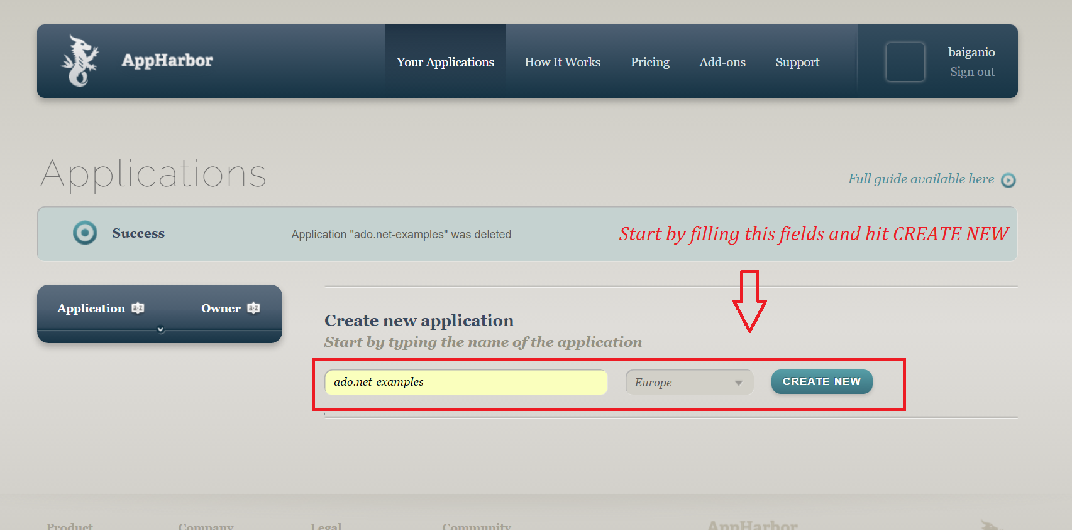

Find the Add-ons or add-on catalog within the project menu. Search below for SQL Server and click the add-on.

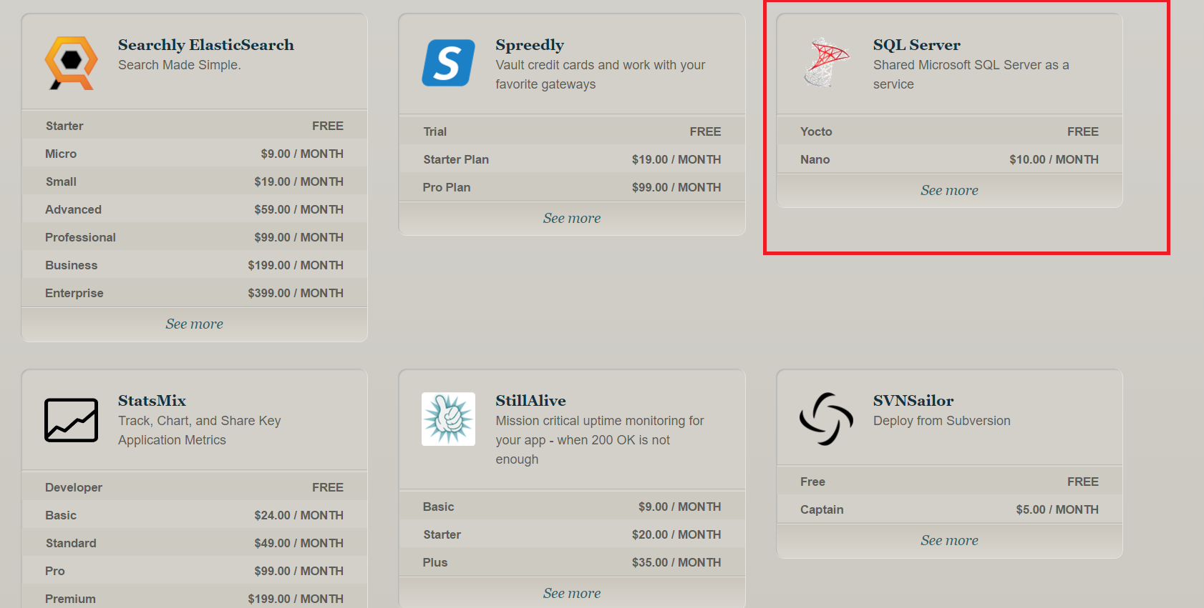

Install Free SQL Server from Yacto.

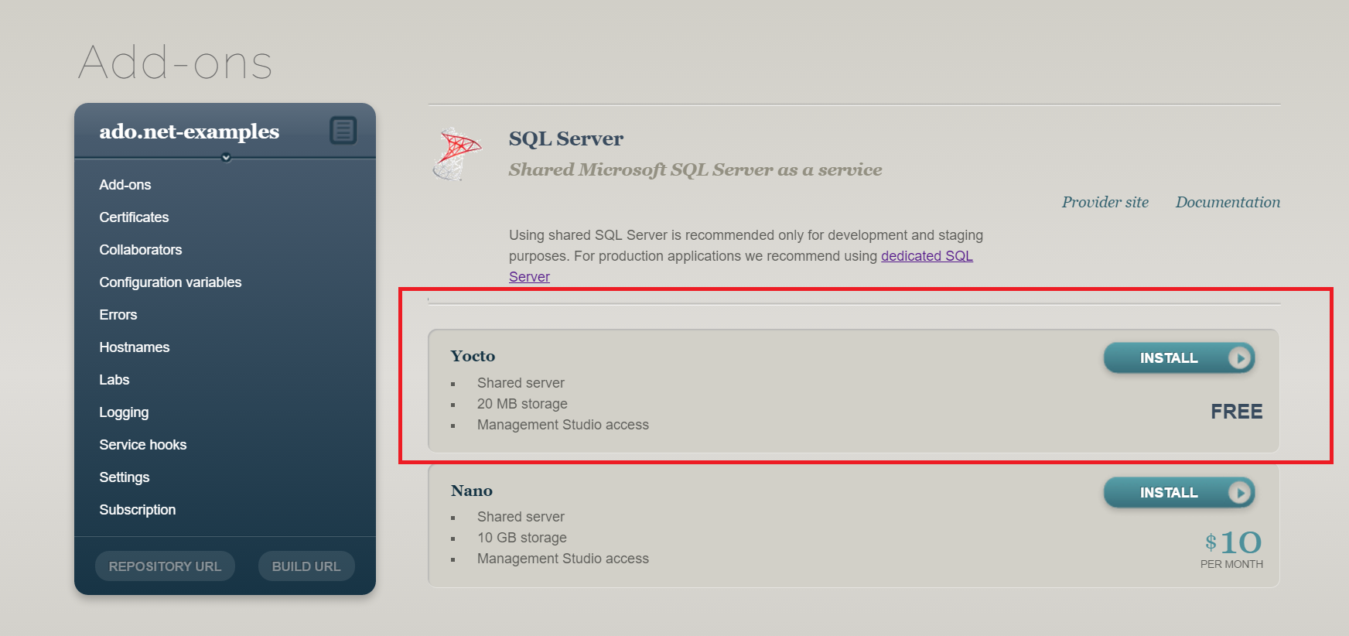

If all is OK we should see this. Configuration variables will be needed later. Now we should configure our repo.

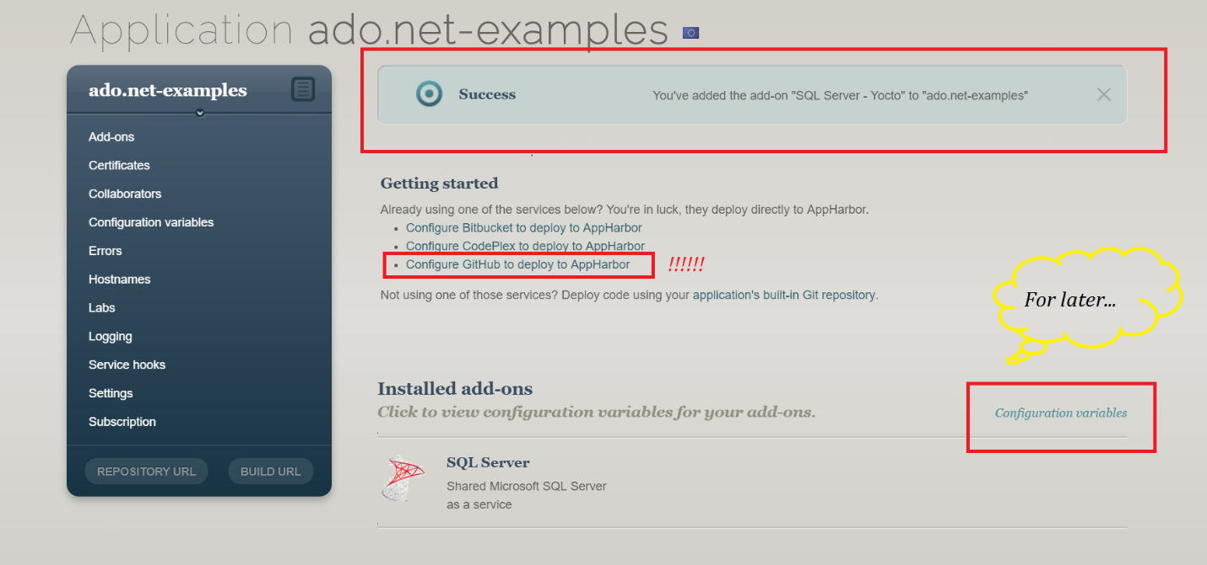

Just do this simple tricks

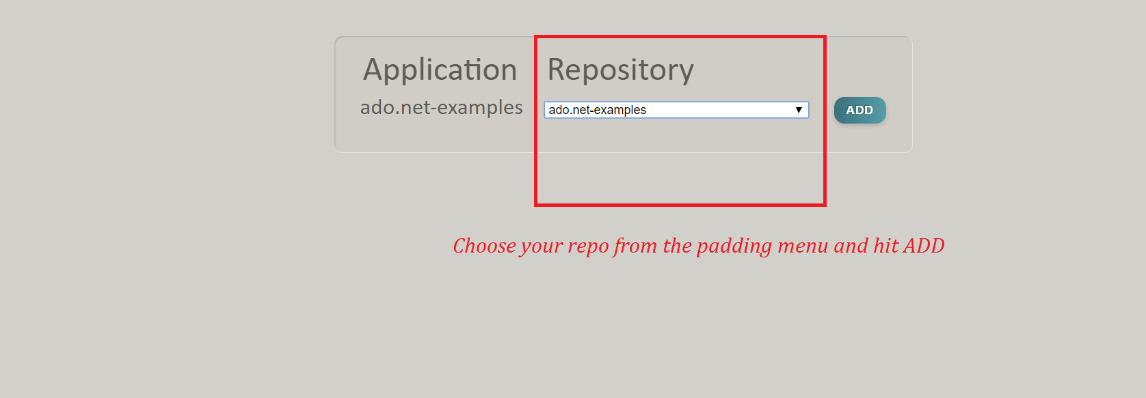

Your setup is done & you can operate upon the app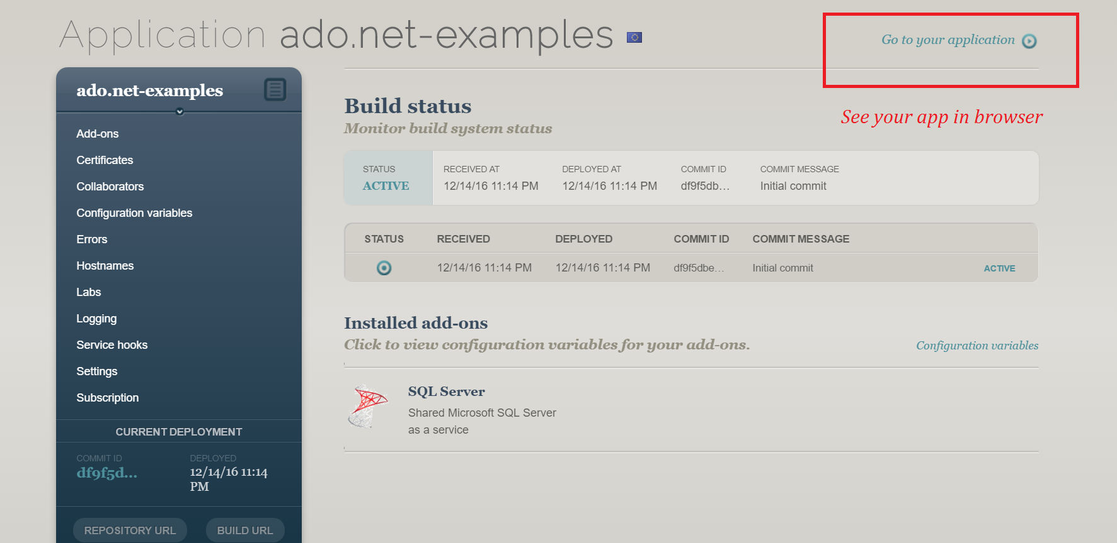

Extract data from configuration variables and paste the in notepad. Connect to the DB with Management Studio.